## ReCAPTCHA

ReCAPTCHA is a service that is provided by google for free to keep websites secure and to maintain data quality as well as possibly presenting data compliance requests such as asking if they comply with certain requirements like user privacy and data protection.

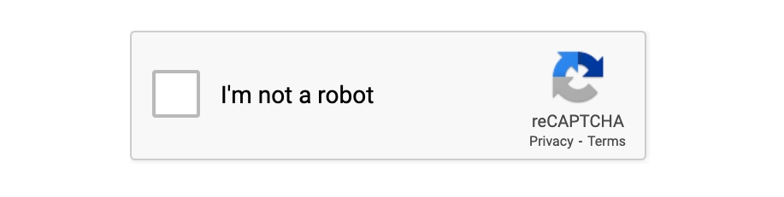

The security aspect of this is immense however the difficulty to implement this is minute therefor making this a great tool to add as it does nothing but improve not only that it has no cost and takes little to no time to add with there are some downsides, and we will look and both the positive and the negatives here in this document.

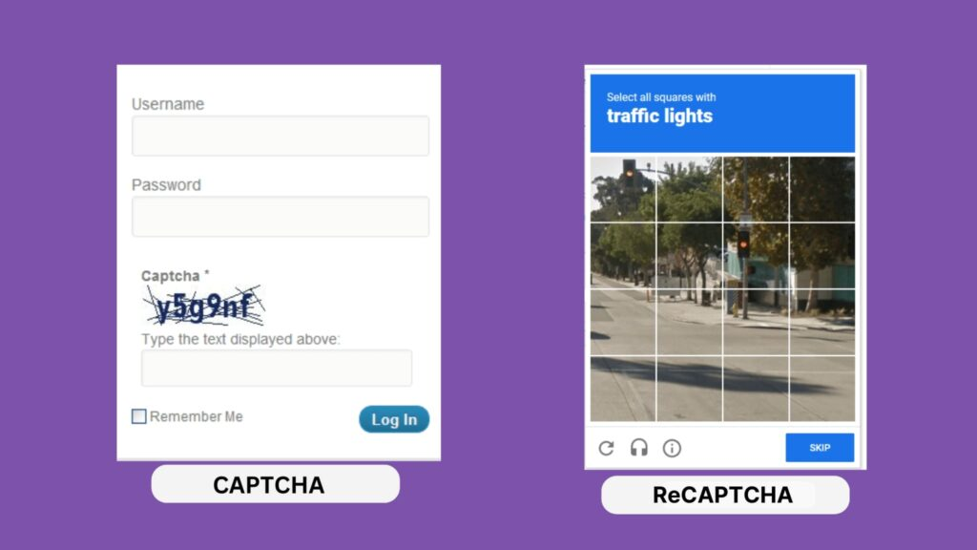

This CAPTCHA is a type of test that is used to access the user and determine whether they are a bot or a human, however most of these tests are distorted text, images and puzzles that need to be interpreted and solved and reCAPTCHA is a more advanced CAPTCHA that has been developed by google which incorporates additional security features and it uses sophisticated machine learning in order to access user behaviour and to find the difference between a bot and a human.

Positives to reCAPTCHA are:

* User friendly the reCAPTCHA is very simplistic although being a challenge case tool the simplicity of it works perfectly making it not feel like a chore however achieving its goal in verifying the user.
* Increased Security as reCAPTCHA is very good at preventing automated bots from passing through your website as well as stopping things such as form spamming which can slow or crash a website also mass amounts of fake account cannot be created.
* Evolving with the use of machine learning algorithms that are what analyses and decide between human or bot meaning that they adapt over time to be both more effective and have less false positive to create an overall better user experience.

Negatives to reCAPTCHA are:

* Privacy concern is one of the major negatives as reCAPTCHA collect user data such as IP addresses, browsing behaviour which has causes some concerns over how much data is being given to google in this case.
* Performance issues due to this challenge tool being slightly resource intensive could potentially result in slower loading times.
* Dependency on google as reCAPTCHA is solely run by google itself if there are any server issues there is no alternative meaning disruptions will be unavoidable.